# Coal Lab Project

# >>>>>>>>>>Balloon Shooting Game<<<<<<<<<<<<

## ~Vision:

Our main idea for this project is to implement a interactive and graphical game in emu 8086. Using some commands in graphical interface of assembly language.

## ~Working:

Basically the game interface run in command prompt. In this game there are two actors one is the hooting gun and the other one is the target represented by a balloon moving in a line in Command prompt and the user shoots the gun by simply pressing a certain key on keyboard. The gun will be placed somewhere on the wall of command prompt and the balloon will be moving in front of that gun but in a line the movement of balloon is synchronized with that line when the balloon crosses the boundary of command prompt another balloon will be executed from the other side and so on unless until user loss the game or skip it by clicking exit button on keyboard after that the final score will be displayed on screen and the number of missed balloons will be shown on screen and the number of hits and number of missed balloons will be shown on command prompt on runtime.

## Interface:

When user run the program the following screen will be shown:

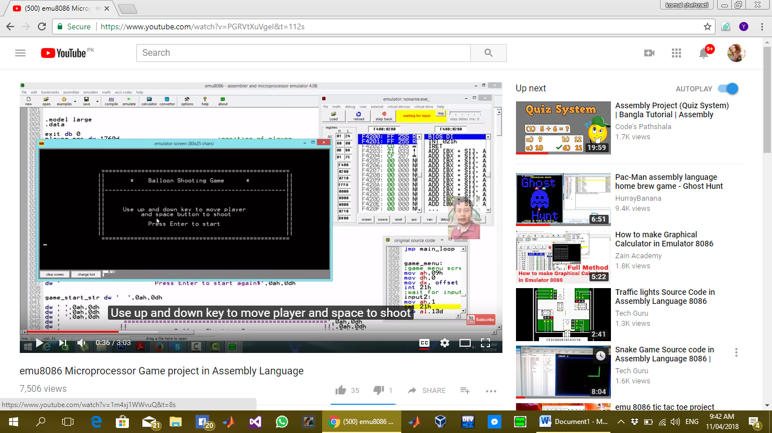

The layout of our game is:

Here on the left wall of command prompt a red colour gun is placed and the purple one is the balloon on the centre of command prompt which moves in vertical direction and when it hits the wall on upper side of Command prompt next balloon will be executed from the lower side of command prompt.

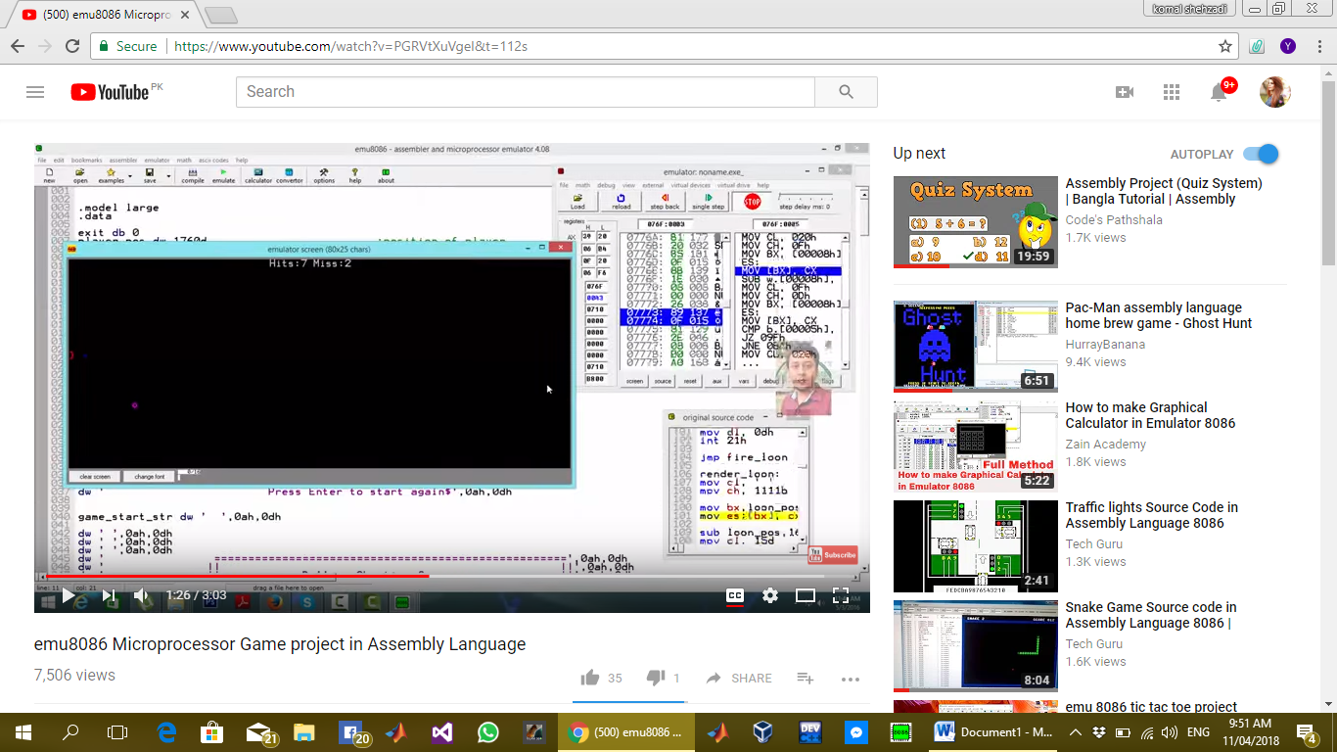

## Type of Commands:

We are using multiple labels and commands for graphical movement of objects and to prompt the user and score we are using data segment.